EXPERIMENT NO. 12
UML DIAGRAMS FOR A COLLEGE SECURITY MANAGEMENT
SYSTEM
AIM
To design the Class diagram, Use Case diagram and Activity diagram for a Security
Management System that manages the security personnel of a college.
SOFTWARE / TOOLS REQUIRED
- Umbrello UML Modeller / StarUML
- Windows / Linux PC
PROCEDURE
- Step 1: Launch the UML Modeling Tool
- Open Umbrello UML Modeller.
- Create a new UML project.
- Save the project with the name &quot;Online Security Management System.&quot;
Step 2: Analyze the Problem Statement
- Read the given problem carefully.
- Identify the main functionalities of the system.
- Determine the actors, classes, and activities involved.
- Plan the structure of the required UML diagrams.
Step 3: Create the Class Diagram
- Add a new Class Diagram to the project.
- Create the required classes such as Security Personnel, Duty Schedule, Campus Location,
- Leave, Salary, Administrator, and Attendance.
- Add suitable attributes for each class.
- Add appropriate methods for each class.
- Establish relationships such as association, aggregation, composition, and inheritance
wherever required.
- Verify that the diagram represents the Online Security Management System accurately.
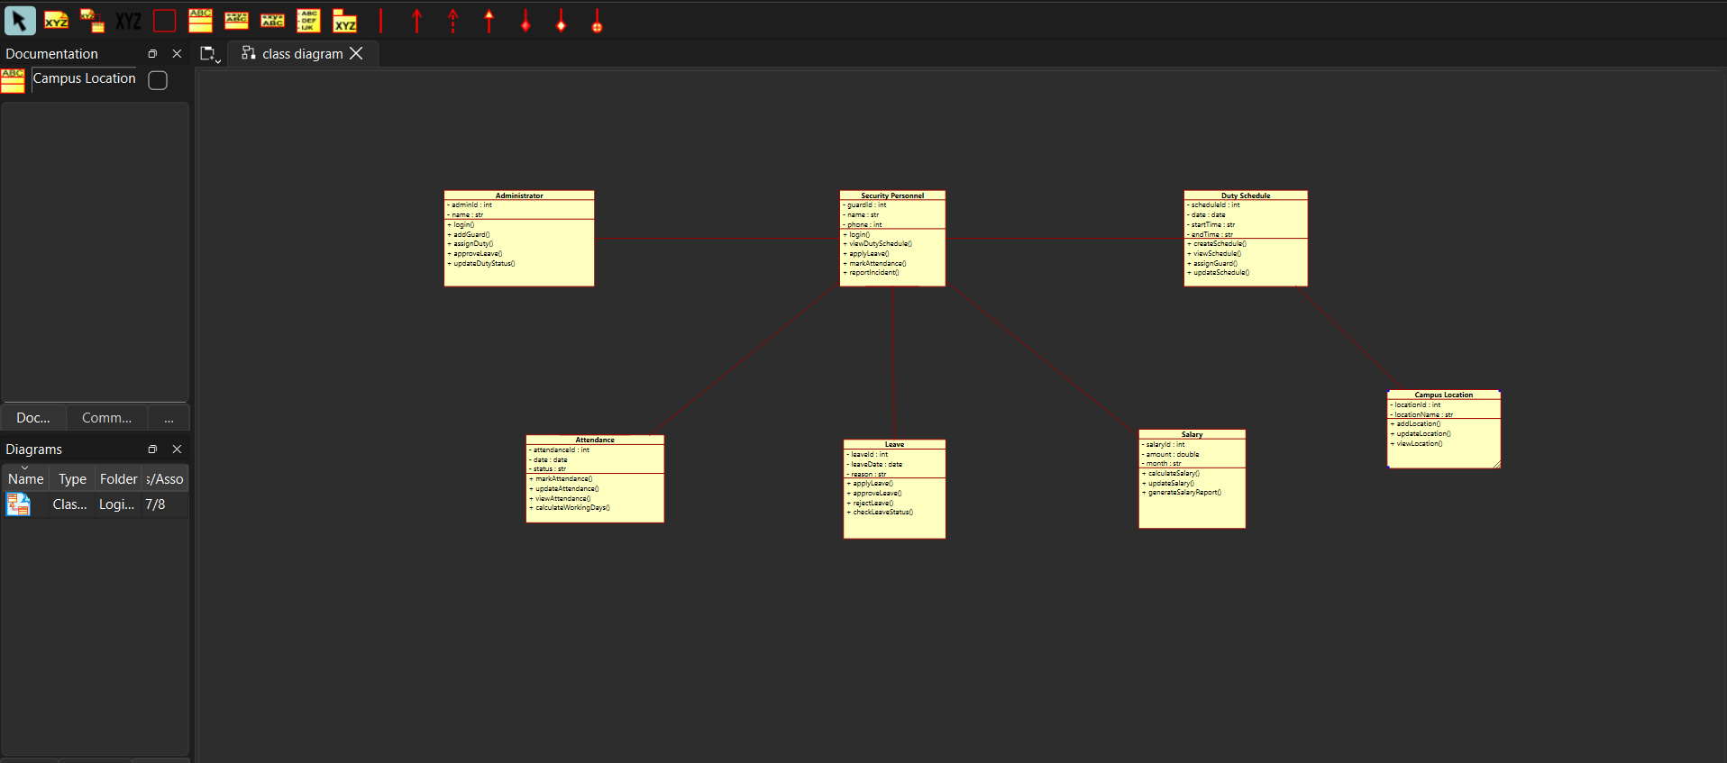
Step 4: Create the Use Case Diagram
- Add a new Use Case Diagram.
- Create the actors such as Administrator, Security Personnel, and Accounts Officer.
- Add use cases including Login, Assign Duty, View Duty Schedule, Apply Leave, Approve
- Leave, Record Attendance, Update Duty Status, Calculate Salary, Generate Salary Report,
- and Logout.
- Connect each actor with the corresponding use cases using association relationships.
- Verify that all required system functionalities are included.
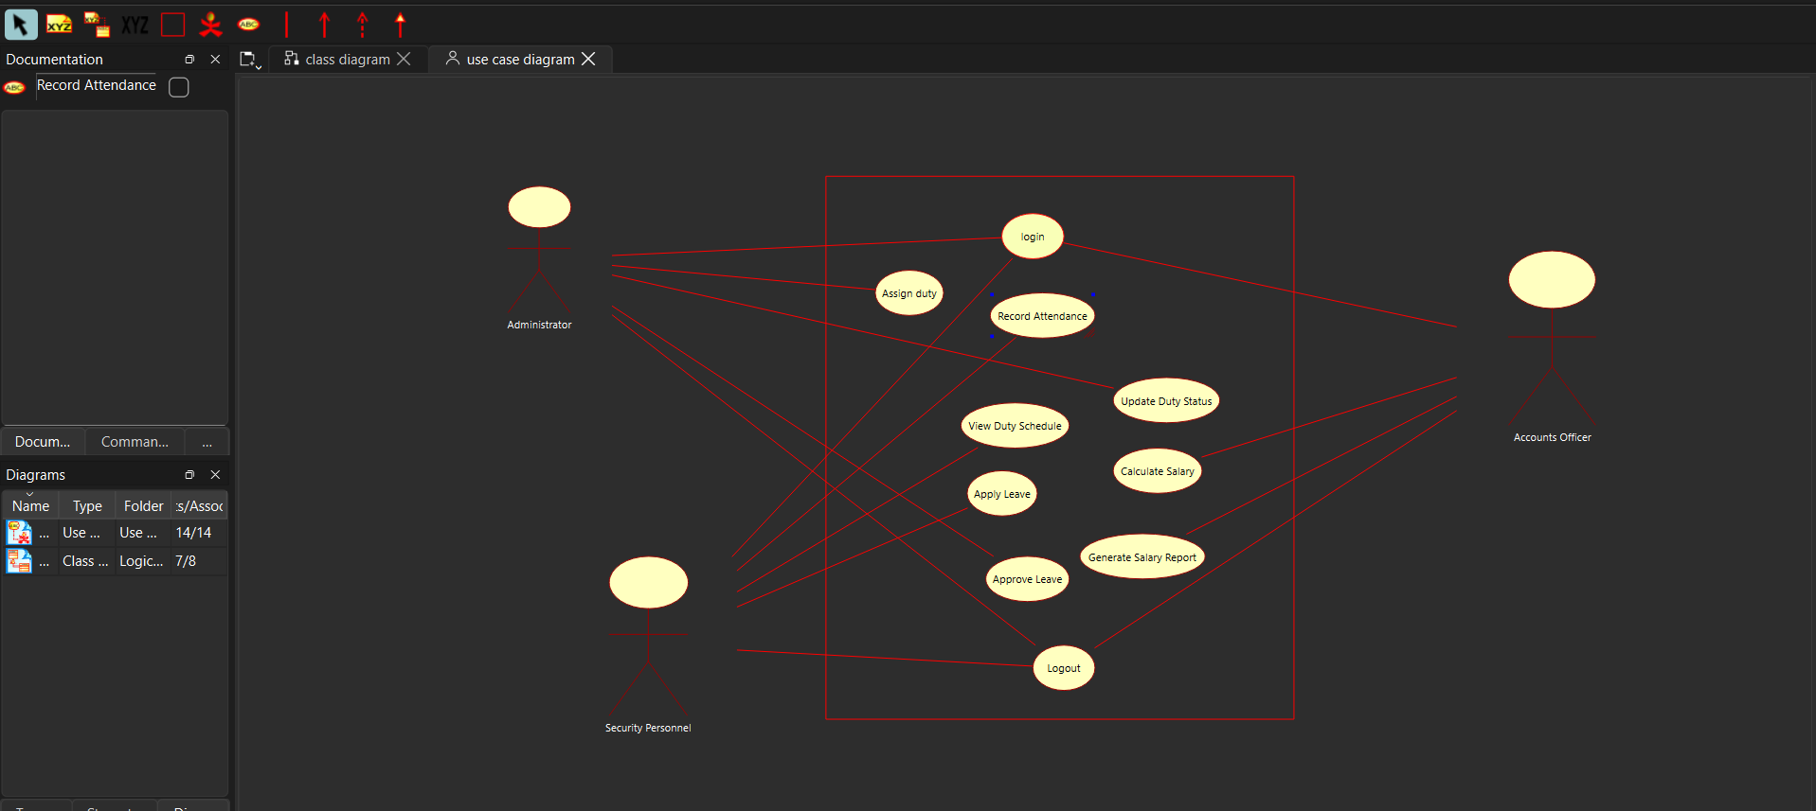
Step 5: Create the Activity Diagram
- Add a new Activity Diagram.
- Insert the Initial Node to represent the start of the workflow.
- Create activities such as Login, Assign Duty, View Duty Schedule, Perform Duty, Apply
- Leave, Approve Leave, Record Attendance, Calculate Salary, Generate Salary Report, and
- Logout.
- Add decision nodes wherever necessary to represent conditions such as leave approval.
- Connect all activities using control flow arrows.
- End the workflow using the Final Node.
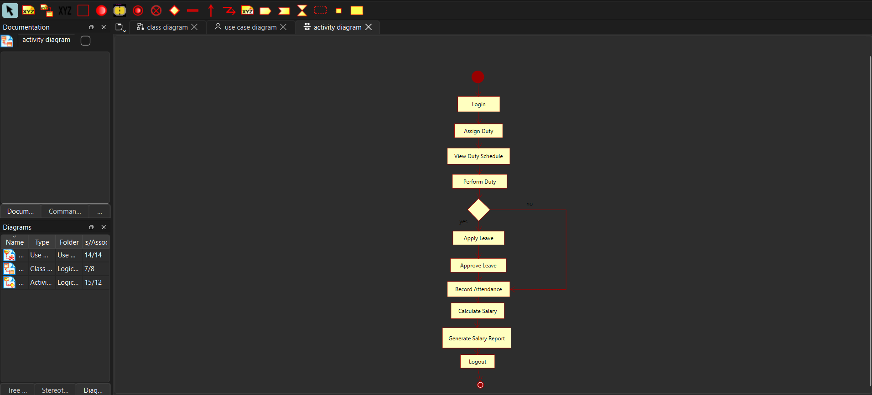
Step 6: Verify the Class Diagram
- Check that all classes contain the required attributes and methods.
- Ensure that all relationships between classes are correctly represented.
- Verify that the diagram satisfies the system requirements.
Step 7: Verify the Use Case Diagram
- Ensure that all actors are connected to the appropriate use cases.
- Verify that every major functionality is represented.
- Check that all associations are correctly connected.
Step 8: Verify the Activity Diagram
- Review the sequence of activities from login to salary generation.
- Verify the control flow and decision nodes.
- Ensure that the workflow accurately represents the Online Security Management System.
Step 9: Save the UML Project
- Save all the created diagrams.
- Store the project with an appropriate file name for future reference and submission.
Step 10: Export the Diagrams
- Export the Class Diagram, Use Case Diagram, and Activity Diagram as image or PDF files.
- Verify that all diagrams
EXPECTED OUTPUT
- Class diagram of the Security Management System with attributes, methods and
- associations.
- Use Case diagram with all actors and use cases inside the system boundary.
- Activity diagram showing the duty and incident-reporting workflow.
RESULT
Thus the Class, Use Case and Activity diagrams for the College Security Management System were designed and verified using the UML modelling tool.

